

Lab # 03
Mobile Application Development – I Fall 2023



Course Instructor: Mr. Qaiser Khan

Lab Instructor | Mr. Muhammad Ahmed
Student Name | Muhammad Taha
CMSID | 518133
Department | Computer Science
Semester | 4th

Lesson Set 3

Object-Oriented Programming in Dart

Purpose | 1. | To understand the principles of object-oriented programming: classes, objects, inheritance, encapsulation, polymorphism, and composition.
 | 2. | To learn how to implement and use classes and objects in Dart for  real-world application scenarios.
 | 3. | To develop problem-solving skills by applying OOP concepts in practical  mobile app development tasks.
Procedure | 1.  2. | Students should read the Pre-lab Reading assignment before coming to the lab.  Students should complete the Pre-lab Writing assignment before entering
 | 3. | the lab.  In the lab, students should complete Labs 3.1 through 3.4 in sequence.
 | 4. | Your instructor will give further instructions on grading and completing the lab.  Students should complete the set of lab tasks before the next lab and get
 |  | them checked by their lab instructor.

Contents | Pre-requisites | Completion Time | Page Number
Pre-lab Reading Assignment | - | 20 min | 3
Pre-lab Writing Assignment | Pre-lab Reading | 10 min | 6
Lab 3
Lab 3.1  OPP principles and Design patterns | Pre-lab reading | 30 min | 5
Lab 3.2  Lab Tasks | Abstract Model + Polymorphism in dart programming | - | 7

PRE-LAB READING ASSIGNMENT
Functions and Parameters | Dart supports defining functions to perform specific tasks, similar to C++.  Basic Function:  void greet() { print('Hello, World!');  }  Functions with Parameters:  void greetUser(String name) { print('Hello, $name!');  }  Returning Values from Functions:  int add(int a, int b) { return a + b;  }  Optional and Named Parameters:  - Optional parameters are enclosed in square brackets.  void greetUser([String name = 'Guest']) { print('Hello, $name');  }  Named parameters allow you to pass arguments by name.
Object-Oriente d Programming in Dart | Dart is fully object-oriented, meaning that everything is an object, including numbers and functions.  Defining a Class:  class Car { String brand; int year;  // Constructor Car(this.brand, this.year);  void displayInfo() {  print('Brand: $brand, Year: $year');  }  }  void main() {  Car car1 = Car('Toyota', 2020); car1.displayInfo();  }  Inheritance:  Dart supports class inheritance where a child class can inherit properties and methods from a parent class.  class Vehicle { void move() {  print('Vehicle is moving');  }  }  class Car extends Vehicle { void honk() {  print('Car is honking');  }}  void main() { Car car = Car();  car.move(); // Inherited method car.honk();  }
Polymorphism and Method Overriding: | Dart allows method overriding in subclasses.  class Animal {  void makeSound() { print('Animal sound');  }  }  class Dog extends Animal { @override  void makeSound() { print('Bark');  }  }  void main() {  Dog dog = Dog(); dog.makeSound();  }
Polymorphism | Polymorphism allows different objects to respond differently to the same method call.  Why we use it:  - Enables flexible and extensible code  - Reduces tight coupling  - Supports future system expansion  In Dart:  - Achieved through inheritance and method overriding

PRELAB WRITING ASSIGNMENT
Fill in the blanks | - In Dart, variables that start with an underscore (_) are considered Private and cannot be accessed outside their library.  - The special method used to initialize the properties of a class when an object is created is called a Constructor.  - When a child class uses the keyword extends to inherit properties and methods from a parent class, this concept is known as Inheritance.  - When a subclass provides its own implementation of a method that already exists in the parent class, this is called method Overriding  - When one class contains an object of another class as one of its properties, this relationship is called Composition in Polymorphism.

Lab 3.2 | Lab Tasks

Task 1: Ride Booking System: Encapsulation & Polymorphism in Dart

Implement Encapsulation
- Create a Ride class with private variables for distance and fare.
- Add validation and a method to calculate fare.
- Prevent direct modification of fare from outside the class.
Implement Polymorphism
- Create a base class RideType with method calculateFare().
- Create subclasses (BikeRide, CarRide, LuxuryRide) that override the method.
- Demonstrate runtime polymorphism using a booking function.
Simulate Complete Booking Flow
- Create a Customer class with private wallet balance.
- Book different ride types.
- Deduct fare from wallet and show success/failure message.

Required Deliverables
Complete Dart source code file
Output screenshot showing:
- Different fare calculations (polymorphism)
Fare Calculation Code:
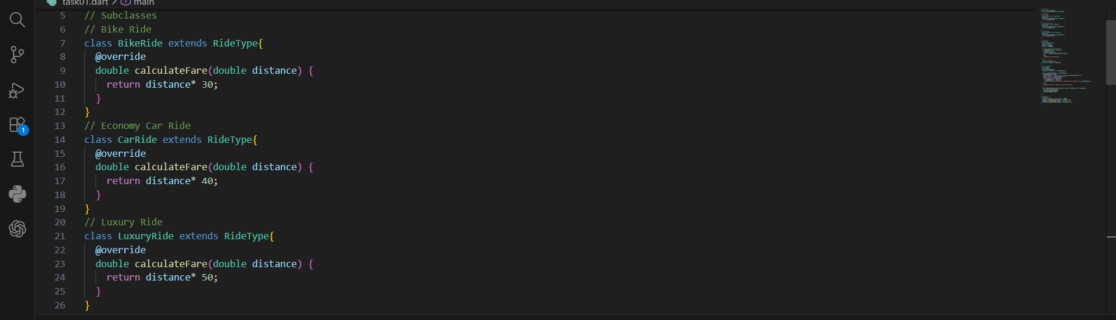
2. Fare Calculation Output:
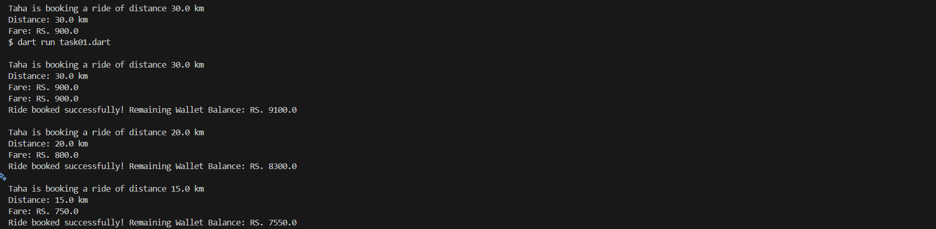

- Encapsulation protection (private variable error or validation)
  - Code Screenshots for the Encapsulation Protection:
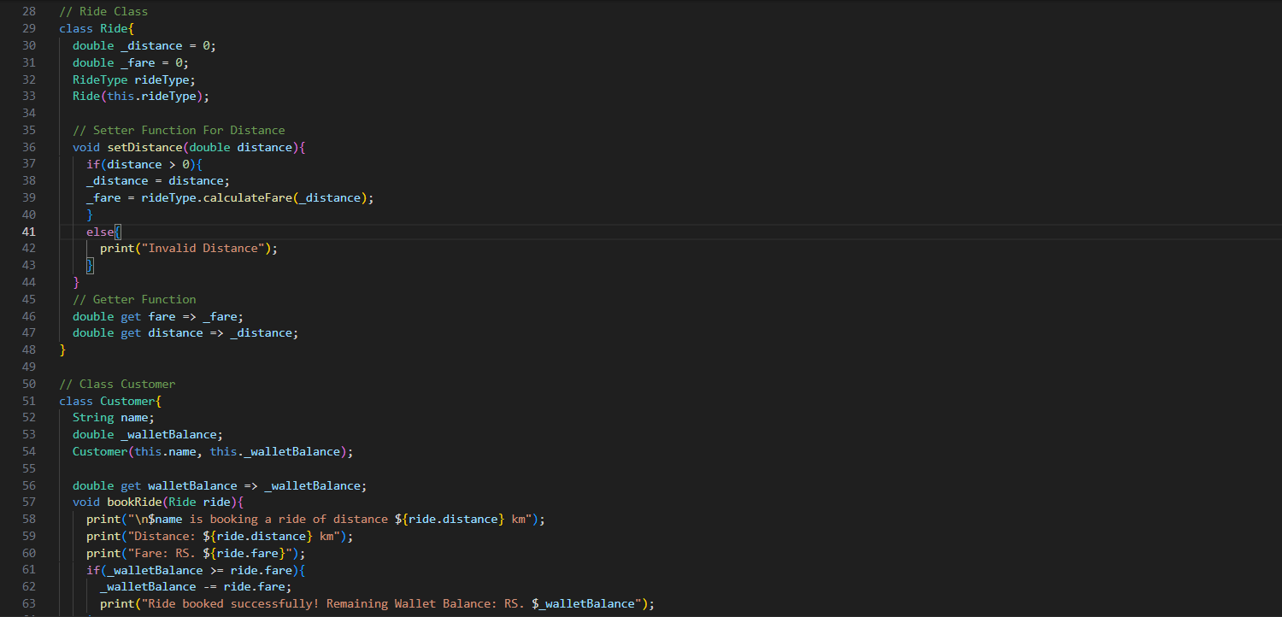

- Successful and unsuccessful payment cases
- Successful Payment Case:
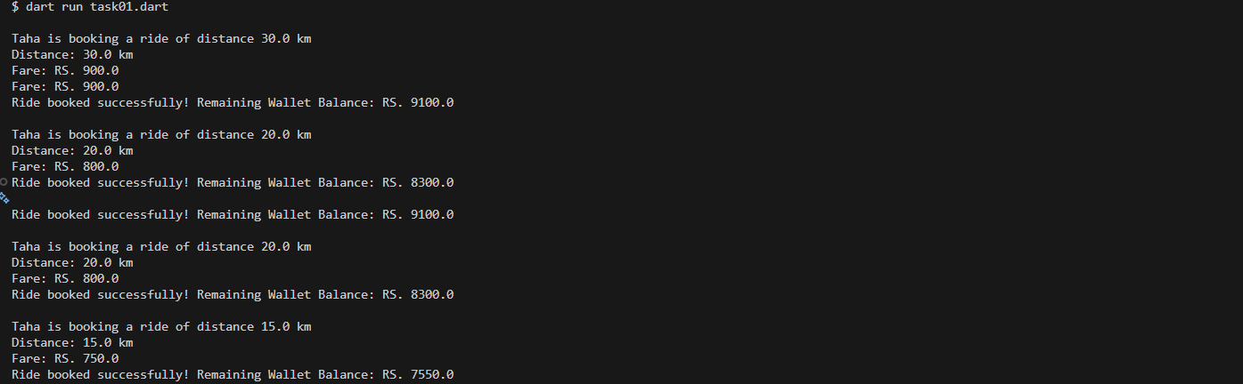
- Unsuccessful Payment Cases
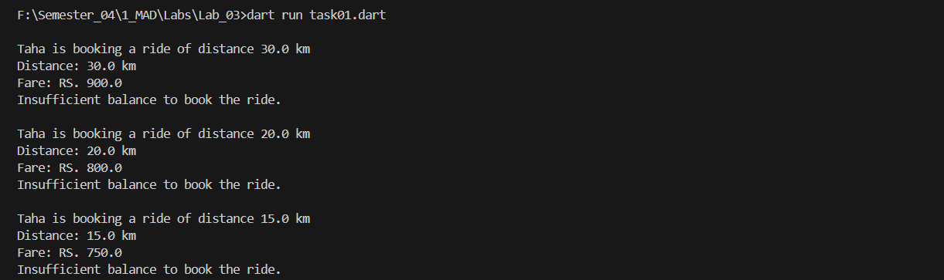
Code:
// Name: Muhammad Taha
// CMS ID: 518133
// Base Class
abstract class RideType{
double calculateFare(double distance);
}
// Subclasses
// Bike Ride
class BikeRide extends RideType{
@override
double calculateFare(double distance) {
return distance* 30;
}
}
// Economy Car Ride
class CarRide extends RideType{
@override
double calculateFare(double distance) {
return distance* 40;
}
}
// Luxury Ride
class LuxuryRide extends RideType{
@override
double calculateFare(double distance) {
return distance* 50;
}
}

// Ride Class
class Ride{
double _distance = 0;
double _fare = 0;
RideType rideType;
Ride(this.rideType);

// Setter Function For Distance
void setDistance(double distance){
if(distance > 0){
_distance = distance;
_fare = rideType.calculateFare(_distance);
}
else{
print("Invalid Distance");
}
}
// Getter Function
double get fare => _fare;
double get distance => _distance;
}

// Class Customer
class Customer{
String name;
double _walletBalance;
Customer(this.name, this._walletBalance);

double get walletBalance => _walletBalance;
void bookRide(Ride ride){
print("\n$name is booking a ride of distance ${ride.distance} km");
print("Distance: ${ride.distance} km");
print("Fare: RS. ${ride.fare}");
if(_walletBalance >= ride.fare){
_walletBalance -= ride.fare;
print("Ride booked successfully! Remaining Wallet Balance: RS. $_walletBalance");
}
else{
print("Insufficient balance to book the ride.");
}
}
void processBooking(Customer customer, RideType rideType, double distance) {
Ride ride = Ride(rideType);
ride.setDistance(distance);
customer.bookRide(ride);
}
}

// Main Fucntion
void main(){
Customer customer = Customer("Taha", 100);
customer.processBooking(customer, BikeRide(), 30);
customer.processBooking(customer, CarRide(), 20);
customer.processBooking(customer, LuxuryRide(), 15);
}

Q: Short explanation (3–4 lines) describing how encapsulation and polymorphism are used in the program

Ans: Encapsulation and Polymorphism are the main concepts of the OOP.
- Encapsulation is used to protect variables from changing from the files outside of the files.
- They are consider private and start with an ‘_’ underscore character.
- Polymorphism is the concept in the OOP which is used to represent and allow different classes to behave differently.
- Polymorphism provide the flexibility in the code
- While using the polymorphism we don’t need to write the abundant codes or any extra code simple code and short code is written and this code can be reused all over the program

To Receive Credit

- By showing up on time for lab, working on the lab solution, and staying until the end of the class period, only then you can receive full credit for the lab assignment.
- Comment on your program heavily. Intelligent comments and clean, readable formatting of your code account for 20% of your grade.
- The lab time is not intended as free time for working on your programming/other assignments. Only if you have completely solved the lab assignment, including all challenges, and have had your work checked off for completeness by your TA/Lab Engineer should you begin the programming/other assignments.

